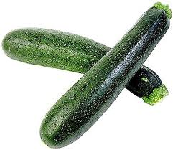
ZUCCHINI

This week, one of the items in the Be Wise Ranch box is zucchini, one of the many forms of summer squash. Zucchini’s range in color from yellow, pale green with grey, pale green, dark green, and almost black. The darker the zucchini, the more nutrients it contains.

Zucchini has over 95% water content and therefore is very low in calories. Also, most of the nutrients are in the skin so it is important to eat the entire squash. It is a good source of the antioxidant vitamin C has a very low glycemic index, ideal for diabetics. See the table below for the nutrition content of 1 medium zucchini.

Nutrition Facts
Zucchini
1 medium

Amount Per Serving
Calories 31 Calories from Fat 3
Total Fat 0g
Saturated Fat 0g
Cholesterol 0mg
Sodium 20mg
Total Carbohydrate 7g
Dietary Fiber 2g
Sugars 3g
Protein 2g
Vitamin A 8% Vitamin C 56%
Calcium 3% Iron 4%

Besides steaming zucchini, there are MANY simple ways to incorporate it into your diet. Some examples are:
- Diced or shredded into tossed salads
- Eaten raw (alone or with dip, such as hummus)
- Stir-fry with other vegetables
- Grilled on the barbeque
- Added to omelets or frittatas
- In breads, muffins, or cakes
- Added to a soup, stew, or pasta sauce
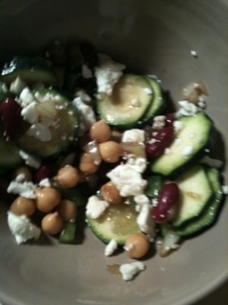
Zucchini Bean Salad

Original recipe: allrecipe.com
Modified by: Ilana Shapiro

INGREDIENTS:

- 3 small zucchini, sliced
- ¾ cup chopped green bell pepper
- ½ cup chopped onion
- 1 (15.5 ounce) can kidney beans, rinsed and drained
- 1 (15.5 ounce) can garbanzo beans, drained and rinsed
- ¼ cup vegetable oil
- 3 tablespoons vinegar
- 1 ½ teaspoon garlic salt
- ¼ teaspoon pepper
- Feta cheese (add to taste)

DIRECTIONS:
In a bowl, combine all ingredients. Cover and refrigerate at least 4 hours, stirring occasionally.

References
- Low Glycemic Index Foods. South Beach Diet page. Available at: http://www. southbeach-diet-plan.com/lowglycemicfoodlist.htm. Accessed September 19, 2011.
- Squash, Summer Squash, Zucchini. NutriData page. Available at: http://nutritiondata.self.com/facts/vegetables-and-vegetable -products/2639/2. Accessed September 19, 2011.
- Picnic Zucchini Bean Salad. Available at: http://allrecipes.com/ recipe/picnic-zucchini-bean-salad/detail.aspx. Accessed September 20, 2011.

