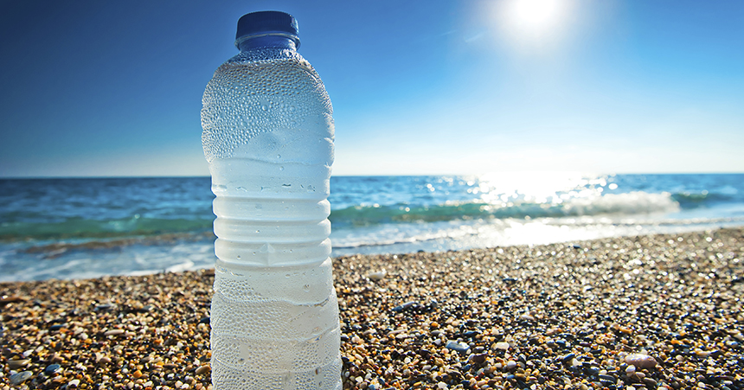
With summer in full swing, it’s important to remember to stay hydrated! But with so much advice being handed out left and right about hydration, it’s hard to know how much— or what— to drink. Here are some important things to keep in mind as you keep cool this summer:

- Water is Key
Water takes up 60% of our body weight, and it is an essential nutrient to keep our body functioning. Water is lost everyday through normal activities, so it is important to fully replenish it. So how much? The Institute of Medicine recommends about 13 cups a day for men and about 9 cups a day for women, but the general advice of “eight cups a day,” is close enough to be safe for most people.

2. Physical Activity Means More Fluids
Everyone knows that as you exercise, you perspire. But did you know that intense
prolonged exercise, especially in the heat, can lead to up to 2.5. liters (about 11 cups) of fluid being lost through perspiration? Factors such as humidity, temperature, and clothing or protective gear can increase this rate as well. This means it is even more important for people engaging in physical activity to stay hydrated! Everyone has different needs, but a general rule of thumb for how much and when to drink for athletes is as follows:
- 5-7 milliliters fluid per kilogram body weight 4 hours before exercise
- 3-5 milliliters fluid per kilogram body weight 2 hours prior to exercise
- 150-350 milliliters fluid every 15-20 minutes throughout exercise
- 1.5 liters fluid per kilogram of body weight lost (of water weight) after exercise

3. There’s More Than Water
Water is ultimately the most recommended fluid to stay hydrated, but it is by no
means the only option. If you find yourself struggling to drink enough water, try some healthy alternatives such as coconut or sparkling water. You can even add some fruit juice or fresh lemon or lime to sparkling water for a flavorful treat. Athletes may find consuming sports drinks to replenish electrolyte and carbohydrate levels to be beneficial if they exercise intensely for over an hour, but make sure to be aware of the sugar content. You can also gain fluids through the food you eat— mainly fruits and vegetables. Try some watermelon, grapefruit, cucumbers or even avocado to increase your fluid intake, and enjoy a delicious, healthy snack!

Hope those tips help you stay hydrated this summer. Check out the recipes below for some more hydration inspiration!

Banana-Pineapple Smoothie

Ingredients:

- 8 oz. plain yogurt
- 1 banana
- 1 (6 oz) can Pine-Orange-Banana juice

Directions:

- Freeze carton of yogurt and allow thawing slightly prior to blending smoothie.
- Put all ingredients into blender.
- Blend until smoothie consistency is reached! If drink is too thick, add orange juice.

Yield: 2 serving

Peach Smoothie

Ingredients:

- 2 medium peeled pitted and sliced fresh peaches or frozen equivalent
- 1 cup milk or yogurt (plain)
- ¼ cup frozen orange juice concentrate
- 4 drops Stevia sweetener
- 1 tsp vanilla
- ½ tsp cinnamon
- 1 cup ice cubes (1½ w/ yogurt)

Directions:

- In blender container combine remaining peaches, milk, juice concentrate, sugar, and vanilla.
- Cover and blend until smooth.
- Gradually add ice cubes through hole in blender lid, blending until smooth after each addition.

Yield: 2 servings
Strawberry Cucumber Water

Ingredients:

- 8 ounces stemmed and thinly sliced strawberries
- ½ cup thinly sliced cucumber

Directions:

- Place the ingredients in a pitcher and add 2 quarts of water
- Refrigerate for 2-4 hours to allow time to infuse
- Before serving, stir well and discard the solids

References:
[Photograph]. Retrieved from
http://www.osteobiflex.com/-/media/osteobiflex/home/articles/summer-joint-nutrition-and-hydration/15_ob_article_hydration.jpg?iar=0&mh=485&w=860&mw=860&h=451&la=en&hash=85954B5BAA5559054324182B21301ABBA512DCA2
[Photograph]. Retrieved from
https://www.healthysmoothiehq.com/wp-content/uploads/2013/06/Pineapple-Banana-Smoothie-Recipe.jpg
Dunford, M., & Doyle, J. A. (2015). Nutrition for sport and exercise. Stamford, CT:
Cengage Learning.
Food Network Kitchens. (n.d.). Strawberry-Cucumber Water Recipe. Retrieved from
http://www.foodnetwork.com/recipes/food-network-kitchen/strawberry-cucumber-water-3362509
Mayo Clinic. (2014, September 5). Water: How much should you drink every day?
Retrieved from http://www.mayoclinic.org/healthy-lifestyle/nutrition-and-healthy-eating/in-depth/water/art-20044256

Post by Janelle Tarmas, Healthy Directions For You Intern

